*Supporting information of*

**A high-resolution map of diffuse groundwater recharge rates for Australia**

Stephen Lee et al.

*Correspondence to:* Stephen Lee ([stephen.lee@cdu.edu.au](mailto:stephen.lee@cdu.edu.au))

# 1. Electronic data files, codes and attribution

This section summarises the datasets and Python codes provided in the supporting information of the paper entitled “A high-resolution map of diffuse groundwater recharge rates for Australia” by Stephen Lee et al.

Attribution for the datasets provided in the supporting information are detailed below.

The following datasets and Python codes are provided electronically in the supporting information:

1. Python code for estimating recharge using a modified version of CMBEAR (Irvine and Cartwright, 2022) can be found in the folder *Python scripts>CMBEAR>Code* as a file named: *CMBEAR2_v1.0.py*. Input and output files related to this code can be found in *Supporting information>Datasets*, and are listed below:
   1. Chloride dataset prior to quality assurance: *Chloride_dataset_20230907_state_id.csv* (**input**)
   2. Chloride dataset after quality assurance: *Clgw_post_qa.csv* (**output**)
   3. Final chloride dataset: *Clgw_final.csv* (**output**)
   4. CMB point recharge dataset prior to the data filtering process: *Chloride_dataset_20230907_state_id_out.csv* (**output**)

**Attribution for gridded input data used in the modified version of CMBEAR**

Gridded input files used for the CMBEAR Python code can be found in the folder *Python scripts>CMBEAR>InputData*, including:

1. Chloride deposition 5th percentile: *cl_deposition_5th.txt*
2. Chloride deposition mean: *cl_deposition_mean.txt*
3. Chloride deposition 95th percentile: *cl_deposition_95th.txt*
4. Chloride deposition standard deviation: *cl_deposition_sd.txt*
5. Chloride deposition skew: *cl_deposition_skew.txt*

are based on Australian chloride deposition rate (1937-2021) gridded map (Wilkins et al., 2022) accessed via <https://data.csiro.au/collection/csiro:53721> by Commonwealth Scientific and Industrial Research Organisation (CSIRO) which is © Commonwealth Scientific and Industrial Research Organisation, and is provided under a Creative Commons Attribution-ShareAlike 4.0 International Licence (<https://creativecommons.org/licenses/by-sa/4.0/>).



Gridded input files used for CMBEAR Python code can be found in the folder *Python scripts>CMBEAR>InputData*, including:

1. Annual precipitation: *rain.txt*
2. Annual potential evapotranspiration (PET): *PET.txt*
3. Aridity index: *aridity.txt*
4. Runoff coefficient: *RC.txt*

are based on Decadal (10-year) rainfall map data (Bureau of Meteorology, 2023b) accessed via <http://www.bom.gov.au/climate/maps/averages/decadal-rainfall/>, Australian Water Outlook PET and runoff (Bureau of Meteorology, 2022c), accessed via <https://awo.bom.gov.au/>, and aridity index (derived from decadal rainfall and PET), by Bureau of Meteorology which is © Commonwealth of Australia 2020, Australian Bureau of Meteorology, and is provided under a Creative Commons Attribution 4.0 International Licence (<https://creativecommons.org/licenses/by/4.0/>).  


**Attribution for chloride data in input and output files provided above**

The following are provided under a Creative Commons Attribution 4.0 International Licence and are subject to the disclaimer of warranties in [section 5](https://creativecommons.org/licenses/by/4.0/legalcode#s5) of that licence:



* Chloride data in the input and output files provided above. Source: (1) Geoscience Australia Portal Hydrochemistry data (Geoscience Australia, 2022) accessed via <https://portal.ga.gov.au/> by Geoscience Australia which is © Commonwealth of Australia and (2) Hydrogeochemistry of Tasmania (Henne and Reid, 2021), Victoria (Gray and Bardwell, 2016e), New South Wales (Gray and Bardwell, 2016a), Queensland (Gray and Bardwell, 2016c), Northern Territory (Gray and Bardwell, 2016b), Western Australia (Gray and Bardwell, 2016f) and South Australia (Gray and Bardwell, 2016d), accessed via <https://data.csiro.au/> by Commonwealth Scientific and Industrial Research Organisation (CSIRO) which is © Commonwealth Scientific and Industrial Research Organisation.
* Chloride data visualised in the paper and this document are based on (1) Geoscience Australia Portal Hydrochemistry data (Geoscience Australia, 2022) accessed via <https://portal.ga.gov.au/> by Geoscience Australia which is © Commonwealth of Australia and (2) Hydrogeochemistry of Tasmania (Henne and Reid, 2021), Victoria (Gray and Bardwell, 2016e), New South Wales (Gray and Bardwell, 2016a), Queensland (Gray and Bardwell, 2016c), Northern Territory (Gray and Bardwell, 2016b), Western Australia (Gray and Bardwell, 2016f) and South Australia (Gray and Bardwell, 2016d), accessed via <https://data.csiro.au/> by Commonwealth Scientific and Industrial Research Organisation (CSIRO) which is © Commonwealth Scientific and Industrial Research Organisation.

Other chloride datasets used in the study are cited in Table S1 and in the paper.

Variables with categorical values within the datasets are explained in the text file: *dataset_codes.txt* which can be found in *Supporting information>Datasets*.

**Attribution for National Groundwater Information System (NGIS) – bore construction information**

Source: NGIS bore construction information accessed via <http://www.bom.gov.au/water/groundwater/explorer/map.shtml> by the states and territories including Australian Capital Territory (Environment, Planning and Sustainable Development Directorate) which is © ACT Environment Protection Authority, New South Wales (Water NSW) which is © WaterNSW, Northern Territory (Department of Environment, Parks and Water Security) which is © Northern Territory Government (Department of Environment, Parks and Water Security), Northern Territory (Power and Water Corporation (Power and Water)) which is © Power and Water Corporation (Power and Water), Queensland (Department of Regional Development, Manufacturing and Water) which is © State of Queensland (Department of Regional Development, Manufacturing and Water), South Australia (Department for Environment and Water) which is © Crown in right of the State of South Australia, Tasmania (Department of Natural Resources and Environment) which is © State of Tasmania (Department of Natural Resources and Environment), Victoria (Department of Energy, Environment and Climate Action) which is © State of Victoria ( Department of Energy, Environment and Climate Action), Western Australia (Department of Primary Industries and Regional Development) which is © State of Western Australia (Department of Primary Industries and Regional Development), and Western Australia (Department of Water and Environmental Regulation) which is © State of Western Australia (Department of Water and Environmental Regulation), and are provided under a Creative Commons Attribution 4.0 International Licence (<https://creativecommons.org/licenses/by/4.0/>).  


1. Python code for the random forest regression model can be found in *Python scripts>RF>Code* as a file named: *RF_recharge_Australia_v1.0.py*. Input and output files related to this code can be found in *Supporting information>Datasets*, and are listed below:
   1. CMB point recharge dataset after the data filtering process: *dat07_u.csv* (**input**)
   2. Latitude and longitude grid coordinates covering Australia and corresponding values from eight spatial datasets: *Australia_grid_0p05_data.csv* (**input**)
   3. Predicted recharge from random forest models for each point in a 0.05° grid of Australia: *model_predictions_aus_8par_grp6_250trees_mf0.33_10fold_out.csv* (**output**)

**Attribution of spatial datasets used in random forest analyses**

Spatial data incorporated into input files provided above are based on:

1. Decadal (10-year) rainfall map data (Bureau of Meteorology, 2023b) accessed via <http://www.bom.gov.au/climate/maps/averages/decadal-rainfall/> by Bureau of Meteorology which is © Commonwealth of Australia 2020, Australian Bureau of Meteorology,
2. Australian Water Outlook PET and runoff data (Bureau of Meteorology, 2022c), accessed via <https://awo.bom.gov.au/> by Bureau of Meteorology which is which is © Commonwealth of Australia 2020, Australian Bureau of Meteorology,
3. Köppen Geiger climate classification maps (Beck et al., 2018), accessed via <https://figshare.com/articles/dataset/Present_and_future_K_ppen-Geiger_climate_classification_maps_at_1-km_resolution/6396959/2> by Beck et al. (2018)
4. Seasonal rainfall (all zones) data (Bureau of Meteorology, 2022a), accessed via <http://www.bom.gov.au/climate/maps/averages/climate-classification/?maptype=seasb> by Bureau of Meteorology which is which is © Commonwealth of Australia 2020, Australian Bureau of Meteorology,
5. Geoscience Australia SRTM 3 sec DEM ground elevation data (Gallant, J. et al., 2009), accessed via <https://ecat.ga.gov.au/geonetwork/srv/eng/catalog.search#/metadata/69888> by Geoscience Australia which is © Commonwealth of Australia,
6. Modelled water table depth data (Fan et al., 2013), accessed via <https://glowasis.deltares.nl/thredds/catalog/opendap/opendap/Equilibrium_Water_Table/catalog.htm> by Fan et al. (2013),
7. Soil and Landscape Grid National Soil Attribute Maps - Depth of Regolith data (Wilford et al., 2018), accessed via <https://data.csiro.au/collection/csiro:11393?q=regolith%20depth&_st=keyword&_str=3&_si=1> by Commonwealth Scientific and Industrial Research Organisation (CSIRO) which is © Commonwealth Scientific and Industrial Research Organisation,
8. Slope data derived from 1” SRTM DEM-S (Gallant, J. and Austin, J., 2012), accessed via <https://data.csiro.au/collection/csiro:5142?q=slope&_st=keyword&_str=93&_si=6> by Commonwealth Scientific and Industrial Research Organisation (CSIRO) which is © Commonwealth Scientific and Industrial Research Organisation,
9. Geodata coast 100K 2004 coastline data (Geoscience Australia, 2004), accessed via <https://ecat.ga.gov.au/geonetwork/srv/eng/catalog.search#/metadata/61395> by Geoscience Australia which is © Commonwealth of Australia,
10. Soil and Landscape Grid National Soil Attribute Maps - Clay (3” resolution) (Malone and Searle, 2022a), accessed via <https://data.csiro.au/collection/csiro:55684?q=clay&_st=keyword&_str=30&_si=1> by Commonwealth Scientific and Industrial Research Organisation (CSIRO) which is © Commonwealth Scientific and Industrial Research Organisation,
11. Soil and Landscape Grid National Soil Attribute Maps - Silt (3” resolution) (Malone and Searle, 2022c), accessed via <https://data.csiro.au/collection/csiro:56750?q=silt&_st=keyword&_str=9&_si=1> by Commonwealth Scientific and Industrial Research Organisation (CSIRO) which is © Commonwealth Scientific and Industrial Research Organisation,
12. Soil and Landscape Grid National Soil Attribute Maps - Sand (3” resolution) (Malone and Searle, 2022b), accessed via <https://data.csiro.au/collection/csiro:55735?q=sand&_st=keyword&_str=28&_si=2> by Commonwealth Scientific and Industrial Research Organisation (CSIRO) which is © Commonwealth Scientific and Industrial Research Organisation,
13. Australian Soil Resource Information System Australian Soil Classification data (CSIRO, 2023), accessed via <https://www.asris.csiro.au/themes/NationalGrids.html> by Commonwealth Scientific and Industrial Research Organisation (CSIRO) which is © Commonwealth Scientific and Industrial Research Organisation,
14. NDVI Average data for Australia (Bureau of Meteorology, 2022d), accessed via <http://www.bom.gov.au/jsp/awap/ndvi/index.jsp> by Bureau of Meteorology which is © Commonwealth of Australia 2020, Australian Bureau of Meteorology,
15. NVIS major vegetation Groups data (Department of Climate Change, Energy, the Environment and Water, 2022), accessed via <https://www.environment.gov.au/fed/catalog/search/resource/details.page?uuid=%7B991C36C0-3FEA-4469-8C30-BB56CC2C7772%7D> by Department of Climate Change, Energy, the Environment and Water which is © Department of Climate Change, Energy, the Environment and Water,

and are all provided under a Creative Commons Attribution 4.0 International Licence (<https://creativecommons.org/licenses/by/4.0/>).  


1. Gridded map output files of recharge rates and recharge-precipitation ratio (R/P) can be found in *Supporting information>Gridded map output files*, including:
   1. R50, R5 and R95 (**outputs**):
      1. *aus_0p05_r05.txt*
      2. *aus_0p05_r50.txt*
      3. *aus_0p05_r95.txt*
      4. *Australia_raster_0p05_r05.tif*
      5. *Australia_raster_0p05_r50.tif*
      6. *Australia_raster_0p05_r95.tif*
   2. R50/P, R5/P and R95/P (**outputs**):
      1. *aus_0p05_r_p_05.txt*
      2. *aus_0p05_r_p_50.txt*
      3. *aus_0p05_r_p_95.txt*
      4. *Australia_raster_0p05_r05.tif*
      5. *Australia_raster_0p05_r50.tif*
      6. *Australia_raster_0p05_r95.tif*

# 2. Collation of chloride data

Table S1. Count of chloride measurements in each dataset compiled for the study.

|  |  |  |  |
| --- | --- | --- | --- |
| **Dataset** | **Dataset name** | **Reference** | **Count** |
| 1 | Geoscience Australia Portal | Geoscience Australia Portal (2022) | 1192 |
| 2 | CSIRO Hydrogeochemical Mapping of the Australian Continent; Hydrogeochemistry of New South Wales: Data Release; Hydrogeochemistry of Northern Territory: Data Release; Hydrogeochemistry of Queensland: Data Release; Hydrogeochemistry of South Australia: Data Release; Hydrogeochemistry of Victoria: Data Release; Hydrogeochemistry of Western Australia: Data Release; Hydrogeochemistry of Tasmania: Data Release. | (Gray et al., 2019; Gray and Bardwell, 2016a, b, c, d, e, f; Henne and Reid, 2021) | 224944 |
| 3 | Dataset collated for the state of South Australia | Broad (2020) | 747 |
| 4 | Visualising Victoria’s Groundwater | FedUni (2015) | 51 |
| 5 | NT Government isotope dataset | Tickell, pers. Comm. (12 April 2022) | 20 |

# 3. Collation of spatial datasets

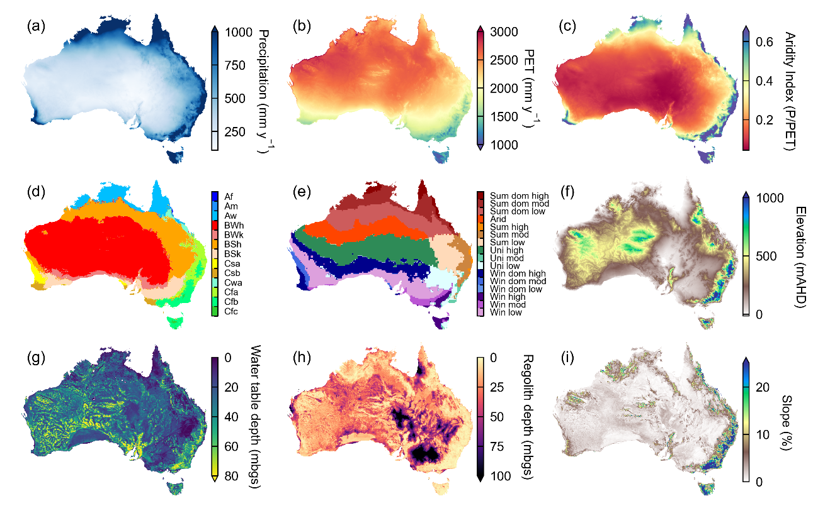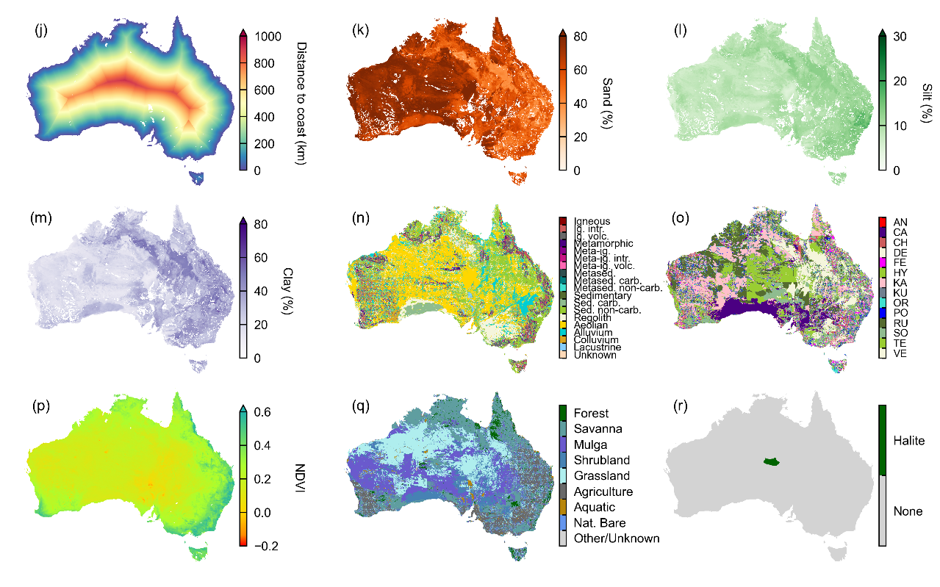

Figure S1. Spatial datasets used in the study, including (a) precipitation, (b) PET, (c) aridity index, (d) Köppen-Geiger, (e) rainfall seasonality, (f) ground elevation, (g) water table depth, (h) regolith depth, (i) slope, (j) distance to coast, (k) sand percentage, (l) silt percentage, (m) clay percentage, (n) surface geology, (o) soil class, (p) NDVI, (q) vegetation class, (r) halite deposit in the Amadeus Basin.

# 3. Data filtering process

The data filtering process is summarised below, detailing the data that were excluded in each step, and the studies in the literature where these have previously been implemented:

1. Remove bores where the screen mid-point ≥150 m below ground surface (bgs) to approximate the upper unconfined aquifer. Process as per Crosbie and Rachakonda (2021) and Crosbie et al. (2022). This step may not remove all bores screened in confined aquifer systems, however, challenges in implementing local-scale analyses to determine aquifer type were at hand due to the large scale of the study. Therefore, some areas affected by this limitation will have recharge areas located a large distance away from the point recharge estimate, and not necessarily be representative of actual conditions.
2. Remove bores where the mean chloride concentration <2 mg L-1 as such low chloride values are closer to the concentration of rainfall and likely not representative of groundwater. These values are more likely the result of poorly sealed/unsealed bores, leading to rainfall contamination, or error in transcription of data, or analytical error. Process as per Crosbie and Rachakonda (2021) and Crosbie et al. (2022).
3. Remove bores where the mean chloride concentration ≥2,000 mg L-1 and where depth to the water table ≤1 m bgs. Bores ≥2,000 mg L-1 chloride are likely to be in groundwater discharge areas or downstream of discharge areas as suggested by Crosbie et al. (2022). Process modified from Crosbie and Rachakonda (2021) and Crosbie et al. (2022).
4. Remove bores where the location intersects the known thick underground halite deposit within the Amadeus Basin. The halite deposit in the Amadeus Basin is the only deposit recorded by Geoscience Australia (Feitz et al., 2019) that is located at a shallow enough depth (i.e., from surface/near-surface to more than 215 m bgs) to be a potential source of chloride for the bores in our dataset.
5. Remove bores that are located <1 km away from the coast. Coastal areas are prone to having large spatial variability of chloride deposition (Guan et al., 2010; Alcalá and Custodio, 2008), which introduces large uncertainty into recharge estimates. Coastal vegetation can substantially increase the interception of dry deposition, which enhances chloride input to aquifers beneath tree canopies (e.g., Deng et al., 2013). This additional source of chloride may not be captured in samplers that generally are positioned in open areas, which could result in an underestimation of recharge through the CMB method. Furthermore, coastal aquifers are likely to have additional chloride sources resulting from seawater intrusion (e.g., Park et al., 2012; Costall et al., 2020) and relict seawater trapped in low permeability sediments during past high sea level stands that have yet to be flushed from the system (e.g., Lenahan and Bristow, 2010; Lee et al., 2016).
6. Remove bores that that have a recharge ratio (R/P) ≥1 (following West et al., 2023). Having an R/P greater than 1 means that annual recharge is greater than annual rainfall, which suggests an additional source of water and chloride.

# 4. Distribution of chloride data

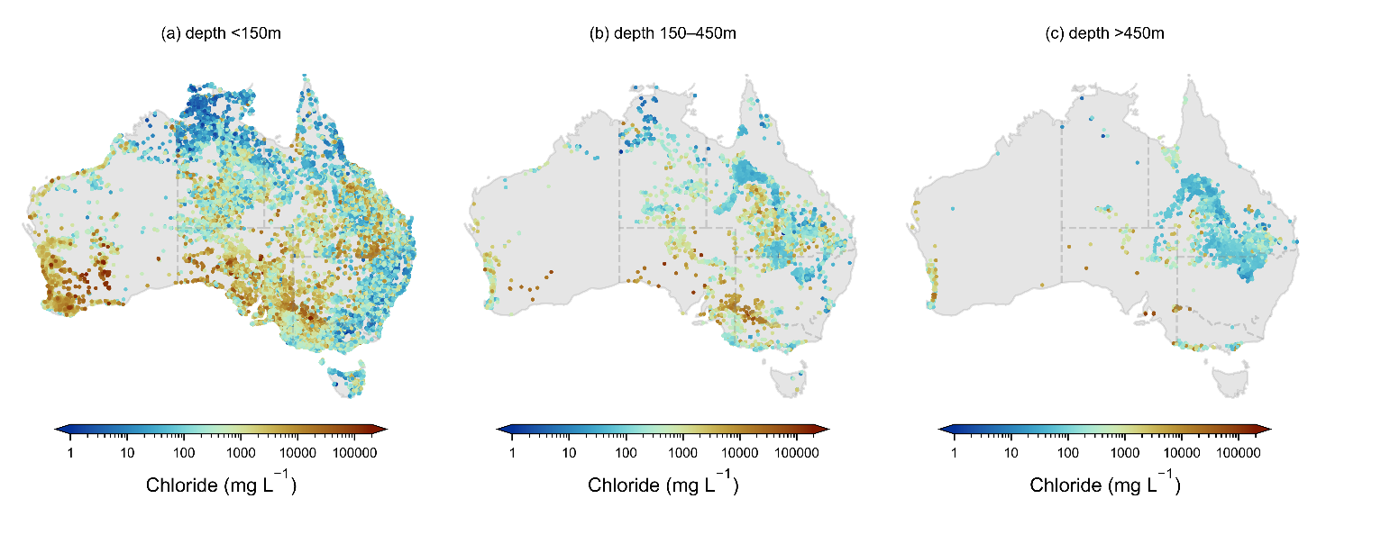

Figure S2. Distribution of groundwater chloride concentrations highlighting (a) the large range and variability in chloride concentrations <150 m below the ground surface (bgs), that does not differ much from Figure 1a in the manuscript (containing values from all depths), (b) chloride concentrations in bores 150–450 m bgs, (c) chloride concentrations in bores >450 m bgs, many of which are located within the Great Artesian Basin.

# 5. Random forest model

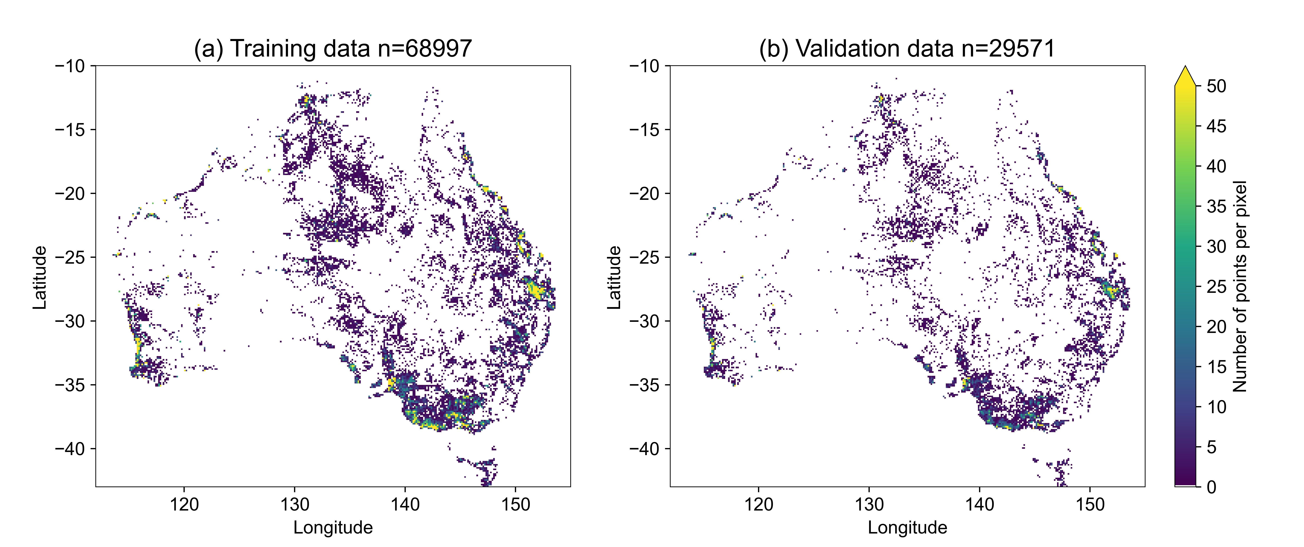

Figure S3. Location and point density of (a) data used to train the random forest regression models; (b) validation data used in the random forest regression models.

Table S2. Results from adding a ninth variable on top of the best performing 8-variable model showing optimal number of trees in each forest, training score (R2) external validation test score (R2), root mean square error (RMSE), and mean absolute error (MAE), where P=precipitation, AI=aridity index, PET=potential evapotranspiration, KG=Köppen-Geiger, RS=rainfall seasonality, DTC=distance to coast, RD=regolith depth, WTD=water table depth, SP=slope percentage, E=elevation, G=geology, SC=soil class, CP=clay percentage, SiP=silt percentage, SaP=sand percentage, NDVI=normalised difference vegetation index, and VC=vegetation category.

|  |  |  |  |  |  |  |
| --- | --- | --- | --- | --- | --- | --- |
| **Model / groupings** | **No. of trees** | **Training score R2** | **Out-of-bag score R2** | **External validation** | | |
| **Test score R2** | **RMSE (mm y-1)** | **MAE (mm y-1)** |
| **9 variable grouping** | | | | | | |
| P, RS, PET, E, DTC, NDVI, CP, SC, RD | 200 | 0.777 | 0.716 | 0.732 | 51.9 | 21.1 |
| P, RS, PET, E, DTC, NDVI, CP, SC, WTD | 400 | 0.777 | 0.717 | 0.731 | 51.9 | 21.2 |
| P, RS, PET, E, DTC, NDVI, CP, SC, G | 150 | 0.769 | 0.715 | 0.731 | 52.0 | 21.2 |
| P, RS, PET, E, DTC, NDVI, CP, SC, SaP | 200 | 0.772 | 0.714 | 0.729 | 52.2 | 21.3 |
| P, RS, PET, E, DTC, NDVI, CP, SC, SP | 150 | 0.776 | 0.714 | 0.729 | 52.2 | 21.4 |
| P, RS, PET, E, DTC, NDVI, CP, SC, VC | 350 | 0.768 | 0.714 | 0.730 | 52.1 | 21.3 |
| P, RS, PET, E, DTC, NDVI, CP, SC, KG | 200 | 0.769 | 0.715 | 0.731 | 52.0 | 21.2 |
| P, RS, PET, E, DTC, NDVI, CP, SC, AI | 200 | 0.773 | 0.716 | 0.732 | 51.8 | 21.1 |
| P, RS, PET, E, DTC, NDVI, CP, SC, SiP | 250 | 0.770 | 0.715 | 0.730 | 52.0 | 21.2 |

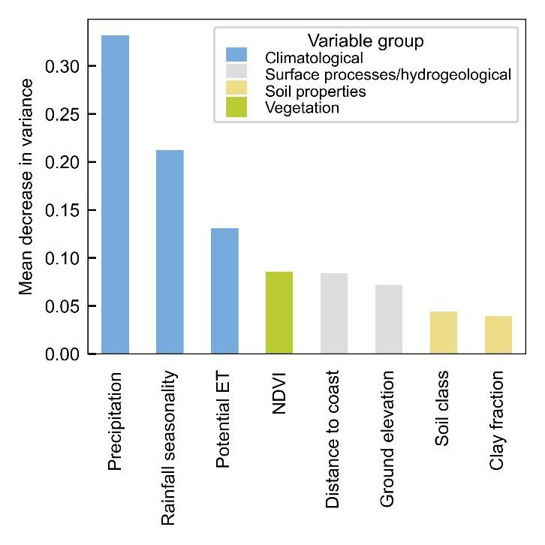

Figure S4. Mean feature importance through mean decrease in variance for the R5 best performing 8-variable model (250 trees). The features are grouped according to climatological, surface processes/hydrogeological, soil properties and vegetation variable groups depicted in Table 1 of the manuscript.

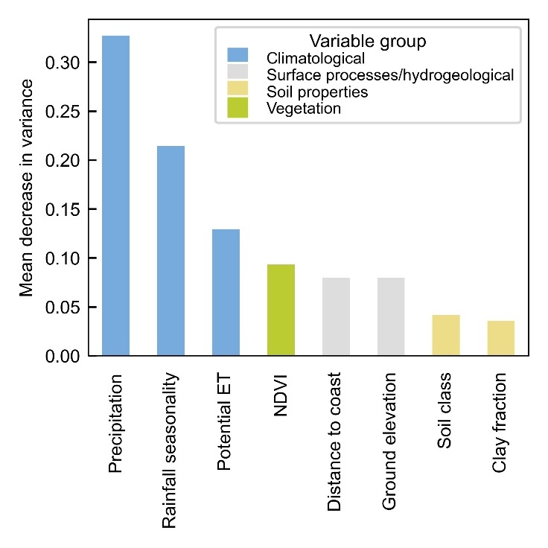

Figure S5. Mean feature importance through mean decrease in variance for the R95 best performing 8-variable model (250 trees). The features are grouped according to climatological, surface processes/hydrogeological, soil properties and vegetation variable groups depicted in Table 1 of the manuscript.

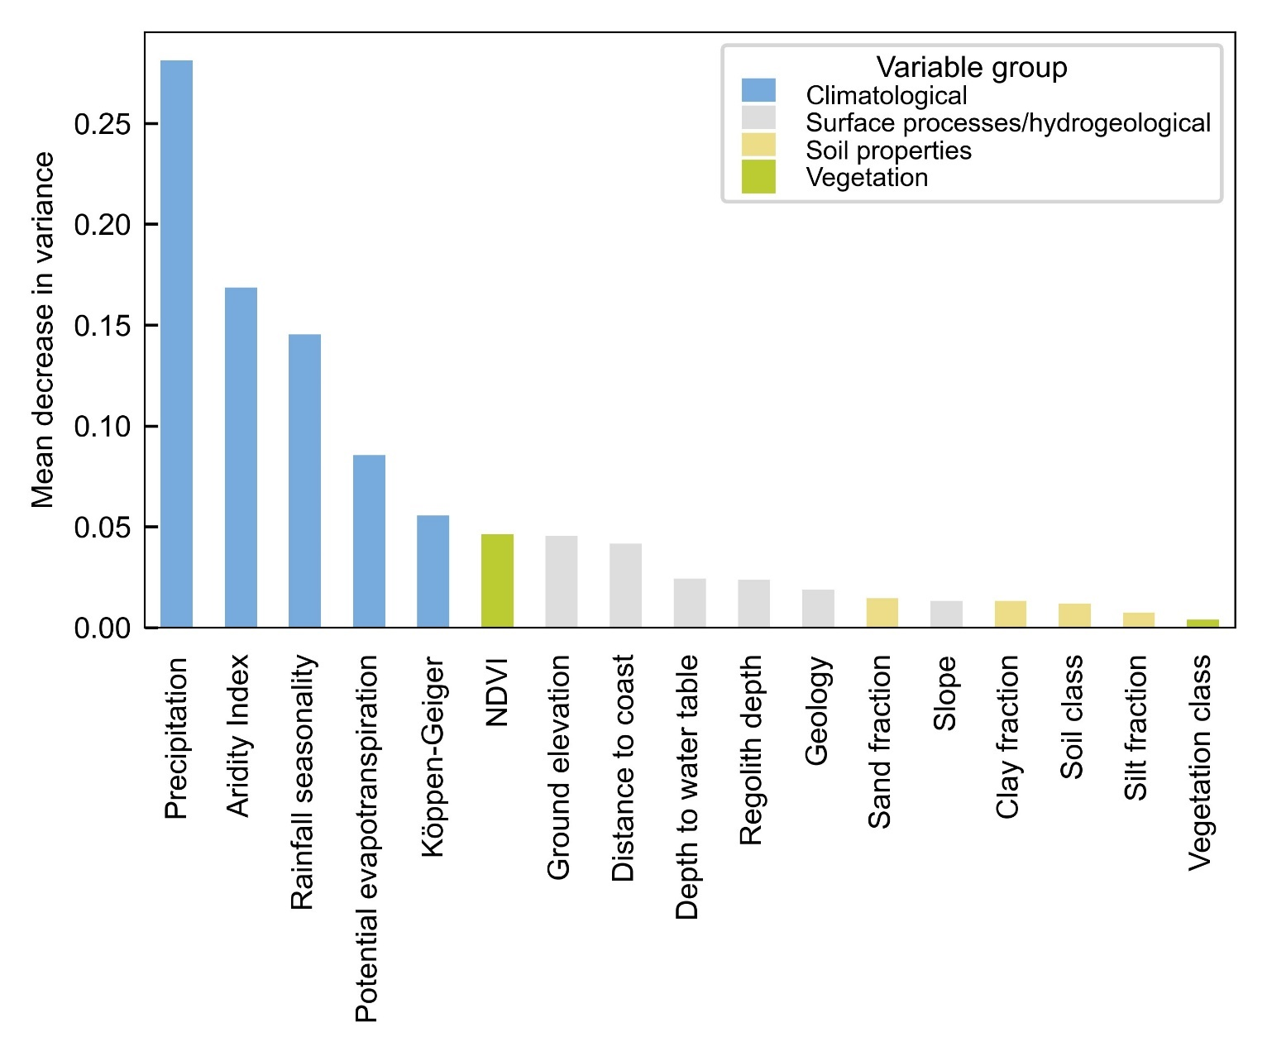

Figure S6. Mean feature importance through mean decrease in variance for the R50 all-variable model (200 trees). The features are grouped according to climatological, surface processes/hydrogeological, soil properties and vegetation variable groups depicted in Table 1 of the manuscript.

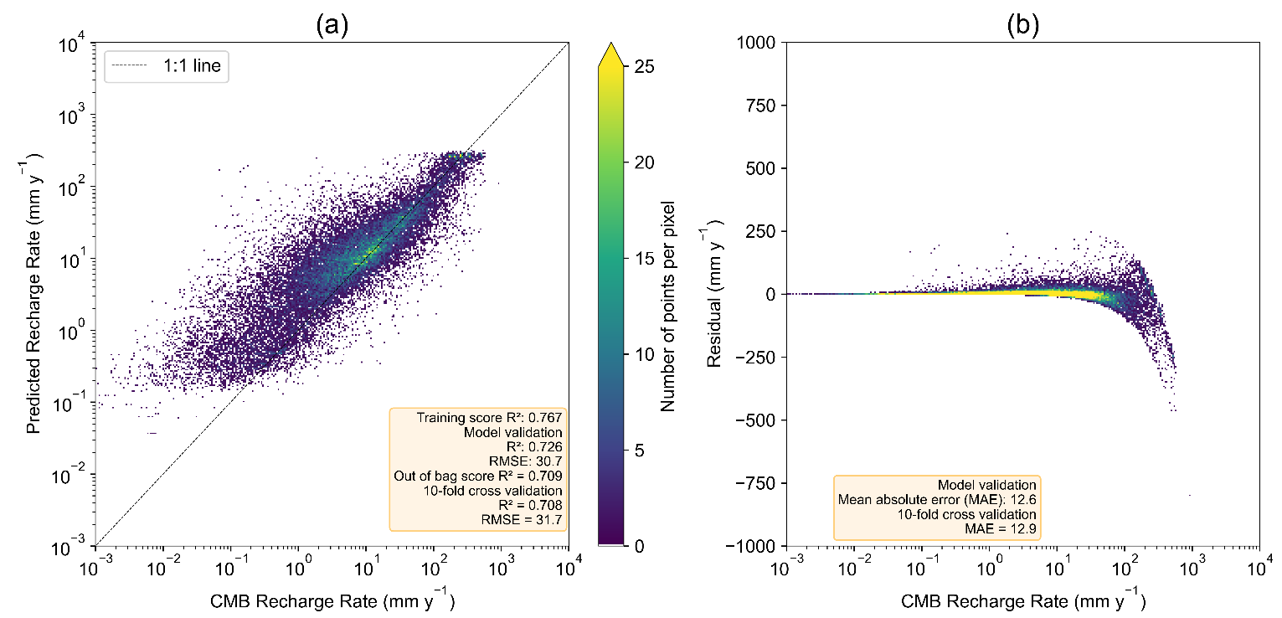

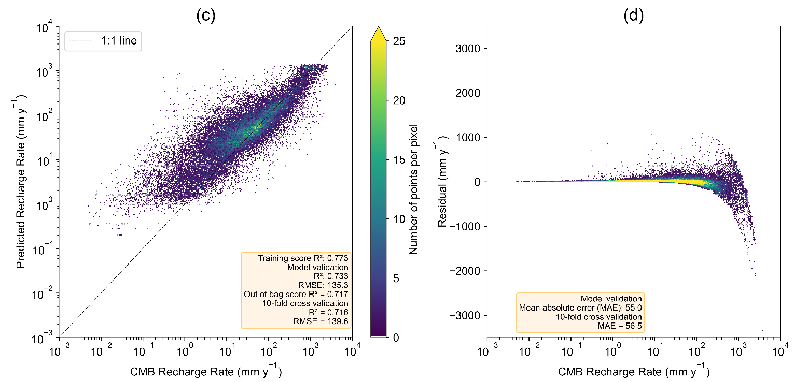

Figure S7. Model validation results for the selected model trained using 250 trees, showing: (a) CMB recharge (R5) versus predicted recharge, showing 1:1 line, (b) CMB recharge (R5) versus residuals (predicted minus CMB recharge), (c) CMB recharge (R95) versus predicted recharge, showing 1:1 line, and (d) CMB recharge (R95) versus residuals (predicted minus CMB recharge). Point density as the number of points per pixel, is shown on all plots.

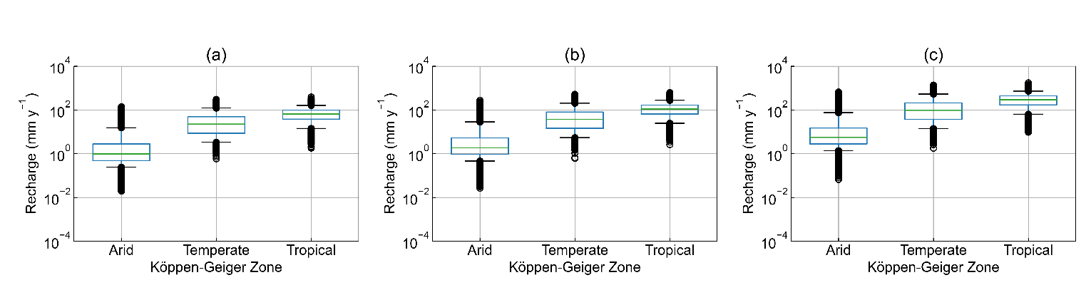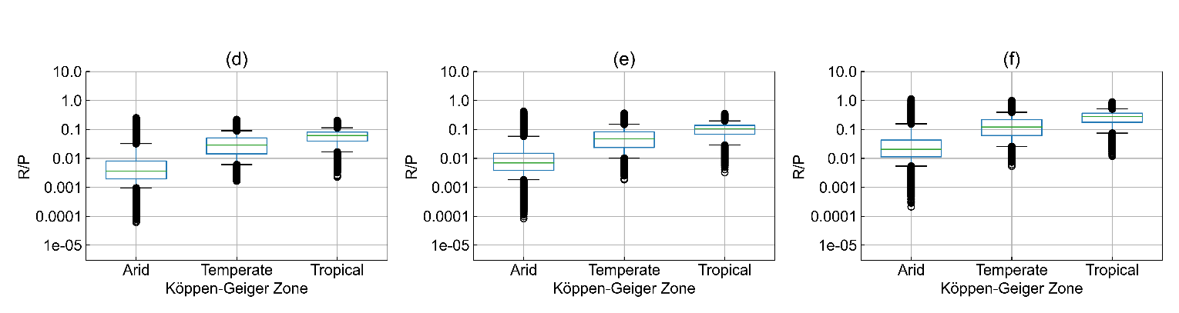

Figure S8. Boxplots showing the distribution of modelled recharge values (a) R5, (b) R50, (c) R95, and modelled recharge ratios (d) R5/P, (e) R50/P, (f) R95/P) categorised by arid, temperate and tropical Köppen-Geiger zones.

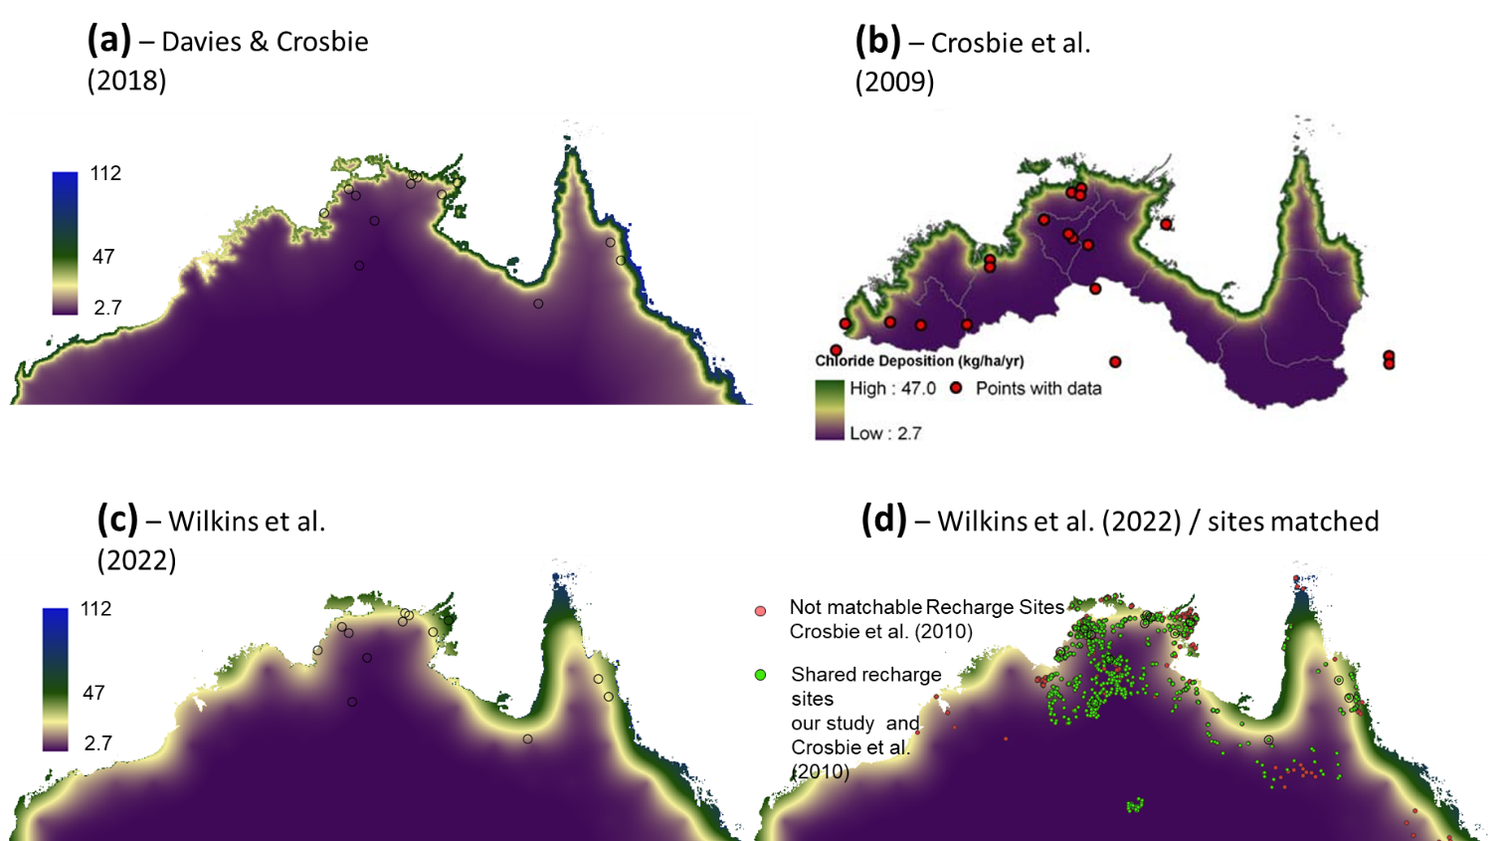

Figure S9. Maps showing gridded deposition maps from (a) Davies and Crosbie (2018), (b) Crosbie et al. (2009), (c) Wilkins et al. (2022) and (d) Wilkins et al. (2022) and recharge sites that were able to be matched (green) and unable to be matched (red) to those in our study.

# 6. Comparison of our point dataset with Moeck et al. (2020) and Crosbie et al. (2010)

Only a limited comparison can be made between our point recharge dataset and Moeck et al. (2020) and Crosbie et al. (2010) due to the following reasons:

1. The Moeck et al. (2020) dataset did not provide information on the estimation method or bore IDs, and only approximate location information. Thus, identifying specific bores to allow like-for-like analyses is not possible. Only 346 out of 4,579 Moeck et al. (2020) estimates could be approximately paired with a bore using matching latitudes and longitudes.
2. However, the Crosbie et al. (2010a) study (data contained within the Moeck dataset) collated a dataset of Australian recharge estimates (n=4,360), presenting the data in a spreadsheet. This spreadsheet also included the recharge estimation method/technique used in the original study as well as in some cases, the bore identifier.
3. Approximately 60 % of the Crosbie et al. (2010a) dataset was collated from Crosbie et al. (2009). These recharge estimates were flagged by Crosbie et al. (2010a) to have very little quality control. Upon review, we found that their methodology was too different for a meaningful comparison with our study (e.g., they utilise a simple CMB method with a vastly different and outdated chloride deposition map).

For our comparison, we utilise the remaining data from Crosbie et al. (2010a), which comprise datasets from four recharge studies (i.e., Banks et al., 2007a, b; Green et al., 2007; Harrington et al., 1999). Figure S10 compares the recharge rates from these four studies to those matching in our study.

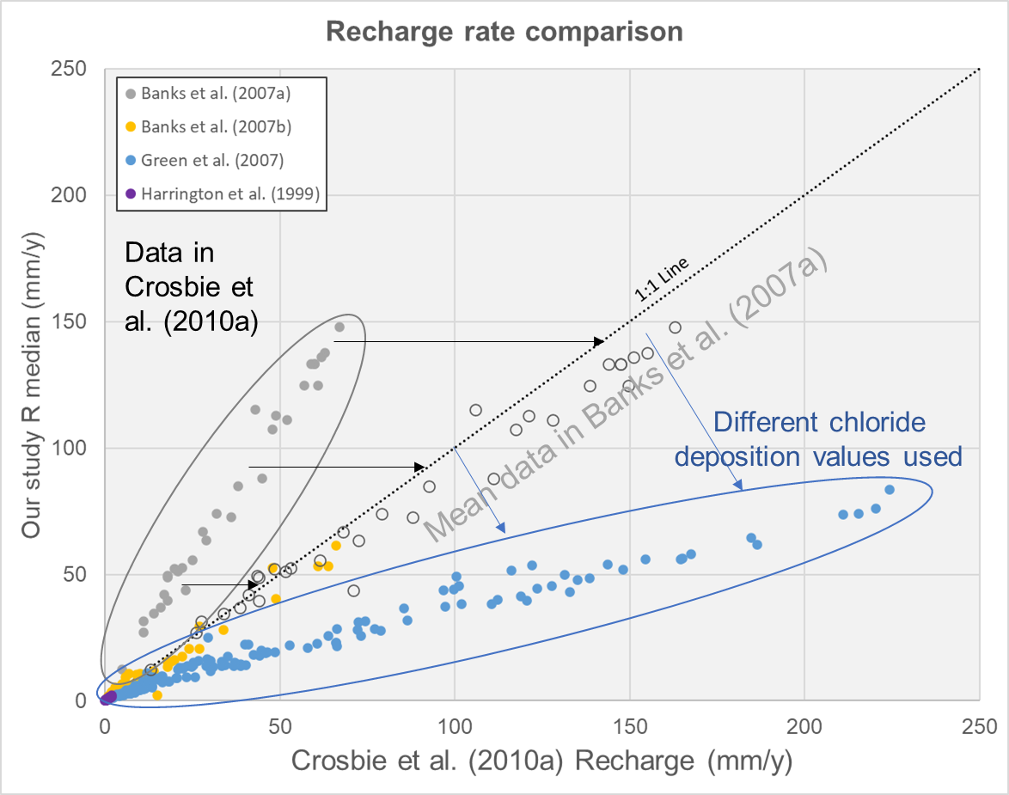

Figure S10. Comparison of recharge rates collated for Crosbie et al. (2010) against median recharge rates (R50) from our study. Hollow grey circles represent the mean recharge rates from Banks et al. (2007b) which plot closer to the 1:1 line than the minimum recharge rates collated in Crosbie et al. (2010). Blue arrows show the deviation of Green et al. (2007) recharge rates from the 1:1 line due to the different chloride deposition values used in their study.

The recharge estimates from Harrington et al. (1999) and Banks et al. (2007b) had similar recharge rates compared to our study (plotting close to the 1:1 line). However, our estimates were consistently higher compared to estimates from Banks et al. (2007a). Our estimates were higher than those from the Banks et al. (2007a) study, as Crosbie et al. (2010a) used the minimum estimates from that study (Fig. S10, solid grey circles. The mean recharge estimates (grey open circles, Fig. S10) effectively lie on our 1:1 line. Similarly, our estimates are consistently lower than those from Green et al. (2007). The large difference between our estimates and Green et al. (2007) can most likely be attributed to their methodology for calculating chloride deposition rates for their study. Further discussion below.

Green et al. (2007) used either an annual rainfall value of 800 mm y-1 or 840 mm y-1, along with a rainfall chloride concentration of 7.2 mg L-1 or 8.4 mg L-1, equating to a range of chloride deposition values between 57 kg ha-1 y-1 and 70.6 kg ha-1 y-1. The chloride deposition values used in Green et al. (2007) are approximately double those used in matching bores from our study, which range from 26.1 kg ha-1 y-1 to 38.0 kg ha-1 y-1. Their average rainfall chloride concentrations were calculated from 3-4 rainfall samples collected over a two-year period, making their chloride deposition rates less reliable. Our chloride deposition rates have been spatially extrapolated from rainfall gauges with a larger number of samples. Additionally, the runoff coefficients used in our study which ranged from 0.1 to 0.39 (average of 0.24) tended to be higher than the 0.1 blanket value used in Green et al. (2007). Both factors have most likely contributed to the recharge rates in Green et al. (2007) being double those calculated in our study.

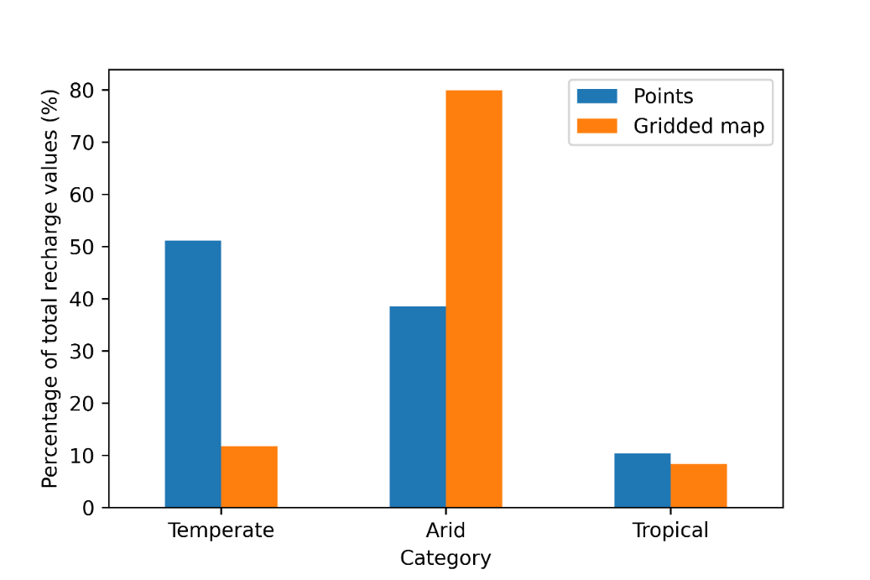

Figure S11. Percentage of points in temperate, arid and tropical Köppen-Geiger zones for the CMB point recharge dataset versus the random forest generated gridded recharge map.

# 7. Producing the gridded recharge maps

The following methodology was used to produce the gridded recharge maps:

1. Spatial gridded datasets were resized to a 0.05° grid where required in QGIS using the GDAL Raster projections Warp (reproject) tool and average resampling method. The georeferenced extents of output files were set to (111.975, 154.025, -44.025, -9.975) [ESPG:4326]. The point sampling tool in QGIS was used to sample each of the seven 0.05° gridded datasets.
2. For the distance to coast dataset a 0.05° grid was generated within an Australia polygon using the QGIS Vector creation Generate points (pixel centroids) inside polygons tool. The QGIS Vector analysis Distance matrix tool was used to calculate the nearest distance to an Australian coastline point file. Linear (N*k x 3) matrix was chosen as the matrix type and the nearest (k) target points was set to 1. The distance values were converted from metres to kilometres.
3. The eight spatial gridded datasets were merged into the one .shp file.
4. The latitude (lat) and longitude (lon) of each point in the grid was added through the QGIS field calculator. The final spatial datasets grid .shp with lat, lon, and each of the eight spatial dataset values was exported as a .csv file.
5. The final spatial datasets grid (.csv) was imported into each of the random forest models and used for prediction of R5, R50 and R95. A .csv file containing lat, lon, R5, R50 and R95 was exported.
6. The .csv file was imported to QGIS and converted to a .shp file. The Rasterize (Vector to Raster) tool in QGIS was used to convert each of the points for R5, R50 and R95 in the .shp file into three rasters (.tif).

# References

Alcalá, F. J. and Custodio, E.: Atmospheric chloride deposition in continental Spain, Hydrological Processes: An International Journal, 22, 3636–3650, https://doi.org/10.1002/hyp.6965, 2008.

Banks, E., Zulfic, D., and Love, A.: Groundwater Recharge Investigation in the Tookayerta Creek Catchment, South Australia, Government of South Australia Department of Water, Land and Biodiversity Conservation, 2007a.

Banks, E., Wilson, T., Green, G., and Love, A.: Groundwater Recharge Investigations in the Eastern Mount Lofty Ranges, South Australia, Government of South Australia Department of Water, Land and Biodiversity Conservation, 2007b.

Beck, H. E., Zimmermann, N. E., McVicar, T. R., Vergopolan, N., Berg, A., and Wood, E. F.: Present and future Köppen-Geiger climate classification maps at 1-km resolution, Sci. Data, 5, 180214, https://doi.org/10.1038/sdata.2018.214, 2018.

Broad, M.: Using Groundwater Age to Inform Aquifer Sustainability, Unpublished Honours Thesis, Flinders University, Adelaide, 2020.

Bureau of Meteorology: http://www.bom.gov.au/climate/maps/averages/climate-classification/?maptype=seasb, last access: 13 December 2022a.

Bureau of Meteorology: http://www.bom.gov.au/climate/maps/averages/decadal-rainfall/, last access: 9 May 2023b.

Bureau of Meteorology: https://awo.bom.gov.au/, last access: 13 December 2022c.

Bureau of Meteorology: http://www.bom.gov.au/metadata/catalogue/19115/ANZCW0503900404, last access: 12 January 2022d.

Costall, A. R., Harris, B. D., Teo, B., Schaa, R., Wagner, F. M., and Pigois, J. P.: Groundwater throughflow and seawater intrusion in high quality coastal aquifers, Scientific reports, 10, 9866, https://doi.org/10.1038/s41598-020-66516-6, 2020.

Crosbie, R., McCallum, J. L., and Harrington, G. A.: Estimation of groundwater recharge and discharge across northern Australia, in: 18th World IMACS Congress and MODSIM09 International Congress on Modelling and Simulation. Modelling and Simulation Society of Australia and New Zealand and International Association for Mathematics and Computers in Simulation, 3053–3059, 2009.

Crosbie, R., Jolly, I. D., Leaney, F. W., and Petheram, C.: Can the dataset of field based recharge estimates in Australia be used to predict recharge in data-poor areas?, Hydrol. Earth Syst. Sc., 14, 2023–2038, https://doi.org/10.5194/hess-14-2023-2010, 2010.

Crosbie, R., Raiber, M., Wilkins, A., Dawes, W., Louth-Robins, T., and Gao, L.: Quantifying diffuse recharge to the Great Artesian Basin groundwater system, CSIRO, 52 pp., https://doi.org/10.25919/fwyj-cp80, 2022.

Crosbie, R. S. and Rachakonda, P. K.: Constraining probabilistic chloride mass-balance recharge estimates using baseflow and remotely sensed evapotranspiration: the Cambrian Limestone Aquifer in northern Australia, Hydrogeol. J., 29, 1399–1419, https://doi.org/10.1007/s10040-021-02323-1, 2021.

CSIRO: https://www.asris.csiro.au/themes/NationalGrids.html, last access: 21 June 2023.

Davies, P. J. and Crosbie, R. S.: Mapping the spatial distribution of chloride deposition across Australia, J. Hydrol., 561, 76–88, https://doi.org/10.1016/j.jhydrol.2018.03.051, 2018.

Deng, Z., Priestley, S. C., Guan, H., Love, A. J., and Simmons, C. T.: Canopy enhanced chloride deposition in coastal South Australia and its application for the chloride mass balance method, Journal of hydrology, 497, 62–70, https://doi.org/10.1016/j.jhydrol.2013.05.040, 2013.

Department of Climate Change, Energy, the Environment and Water: https://www.environment.gov.au/fed/catalog/search/resource/details.page?uuid=%7B991C36C0-3FEA-4469-8C30-BB56CC2C7772%7D, last access: 12 January 2022.

Fan, Y., Li, H., and Miguez-Macho, G.: Global patterns of groundwater table depth, Science, 339, 940–943, https://doi.org/10.1126/science.1229881, 2013.

FedUni: https://www.vvg.org.au, last access: 20 August 2022.

Feitz, A. J., Tenthorey, E., and Coghlan, R. A.: Prospective hydrogen production regions of Australia, Geoscience Australia, 64 pp., http://dx.doi.org/10.11636/Record.2019.015, 2019.

Gallant, J. and Austin, J.: Slope derived from 1" SRTM DEM-S, v4, https://doi.org/10.4225/08/5689DA774564A, 2012.

Gallant, J., Wilson, N., Tickle, P. K., Dowling, T., and Read, A.: 3 second SRTM Derived Digital Elevation Model (DEM) Version 1.0, https://pid.geoscience.gov.au/dataset/ga/69888, 2009.

Geoscience Australia: Geodata Coast 100K 2004, https://pid.geoscience.gov.au/dataset/ga/61395, 2004.

Geoscience Australia: https://portal.ga.gov.au/, last access: 9 January 2022.

Gray, D. and Bardwell, N.: Hydrogeochemistry of New South Wales: Data Release. v1., https://doi.org/10.4225/08/5756B395C68B0, 2016a.

Gray, D. and Bardwell, N.: Hydrogeochemistry of Northern Territory: Data Release. v2., https://doi.org/10.4225/08/5987D4BA86FF7, 2016b.

Gray, D. and Bardwell, N.: Hydrogeochemistry of Queensland: Data Release. v1., https://doi.org/10.4225/08/575A453145914, 2016c.

Gray, D. and Bardwell, N.: Hydrogeochemistry of South Australia: Data Release. v1., https://doi.org/10.4225/08/5756B3BF09204, 2016d.

Gray, D. and Bardwell, N.: Hydrogeochemistry of Victoria: Data Release. v2., https://doi.org/10.4225/08/5987D4751859E, 2016e.

Gray, D. and Bardwell, N.: Hydrogeochemistry of Western Australia: Data Release. v1., https://doi.org/10.4225/08/575CDF378054A, 2016f.

Gray, D., Reid, N., Noble, R., and Giblin, A.: Hydrogeochemical Mapping of the Australian Continent, CSIRO, 109, https://doi.org/10.25919/5d8bb939ef2f2, 2019.

Green, G., Banks, E., Wilson, T., and Love, A.: Groundwater recharge and flow investigations in the Western Mount Lofty Ranges, South Australia, Government of South Australia Department of Water, Land and Biodiversity Conservation, 2007.

Guan, H., Love, A. J., Simmons, C. T., Hutson, J., and Ding, Z.: Catchment conceptualisation for examining applicability of chloride mass balance method in an area with historical forest clearance, Hydrol. Earth Syst. Sci., 14, 1233–1245, https://doi.org/10.5194/hess-14-1233-2010, 2010.

Harrington, G. A., Herczeg, A. L., and Cook, P. G.: Groundwater Sustainability and Water Quality in the Ti-Tree Basin, Central Australia, CSIRO, 1999.

Henne, A. and Reid, N.: Hydrogeochemistry of Tasmania: Data Release. v1., https://doi.org/10.25919/1P8B-G702, 2021.

Irvine, D. J. and Cartwright, I.: CMBEAR: Python‐Based Recharge Estimator Using the Chloride Mass Balance Method in Australia, Groundwater, 60, 418–425, https://doi.org/10.1111/gwat.13161, 2022.

Lee, S., Currell, M., and Cendón, D. I.: Marine water from mid-Holocene sea level highstand trapped in a coastal aquifer: evidence from groundwater isotopes, and environmental significance, Science of the Total Environment, 544, 995–1007, https://doi.org/10.1016/j.scitotenv.2015.12.014, 2016.

Lenahan, M. J. and Bristow, K. L.: Understanding sub-surface solute distributions and salinization mechanisms in a tropical coastal floodplain groundwater system, Journal of Hydrology, 390, 131–142, https://doi.org/10.1016/j.jhydrol.2010.06.009, 2010.

Malone and Searle: Soil and Landscape Grid National Soil Attribute Maps - Clay (3" resolution) - Release 2 (4), https://doi.org/10.25919/hc4s-3130, 2022a.

Malone and Searle: Soil and Landscape Grid National Soil Attribute Maps - Sand (3" resolution) - Release 2 (3), https://doi.org/10.25919/rjmy-pa10, 2022b.

Malone and Searle: Soil and Landscape Grid National Soil Attribute Maps - Silt (3" resolution) - Release 2, https://doi.org/10.25919/2ew1-0w57, 2022c.

Moeck, C., Grech-Cumbo, N., Podgorski, J., Bretzler, A., Gurdak, J. J., Berg, M., and Schirmer, M.: A global-scale dataset of direct natural groundwater recharge rates: A review of variables, processes and relationships, Sci. Total Environ., 717, 137042, https://doi.org/10.1016/j.scitotenv.2020.137042, 2020.

Park, Y., Lee, J.-Y., Kim, J.-H., and Song, S.-H.: National scale evaluation of groundwater chemistry in Korea coastal aquifers: evidences of seawater intrusion, Environmental Earth Sciences, 66, 707–718, https://doi.org/10.1007/s12665-011-1278-3, 2012.

West, C., Reinecke, R., Rosolem, R., MacDonald, A. M., Cuthbert, M. O., and Wagener, T.: Ground truthing global-scale model estimates of groundwater recharge across Africa, Sci. Total Environ., 858, 159765, https://doi.org/10.1016/j.scitotenv.2022.159765, 2023.

Wilford, Searle, Thomas, and Grundy: Soil and Landscape Grid National Soil Attribute Maps - Depth of Regolith (3" resolution) - Release 2 (6), https://doi.org/10.4225/08/55C9472F05295, 2018.

Wilkins, A., Crosbie, R., Louth-Robins, T., Davies, P., Raiber, M., Dawes, W., and Gao, L.: Australian gridded chloride deposition-rate dataset, Data in Brief, 42, 108189, https://doi.org/10.1016/j.dib.2022.108189, 2022.